Product Rating System
Design a product rating system that can perform the following operations:
- Manager can add/edit/delete products
- Manager can Modify the rating of a product listed in the system.
- User can ask the list of all the products along with their rating.
- Manager can ask for the all the products having low ratings and it should be listed according to the catergory.
Class Diagram for the Product Rating System:

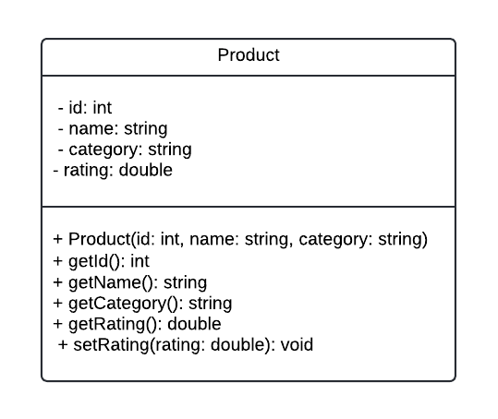
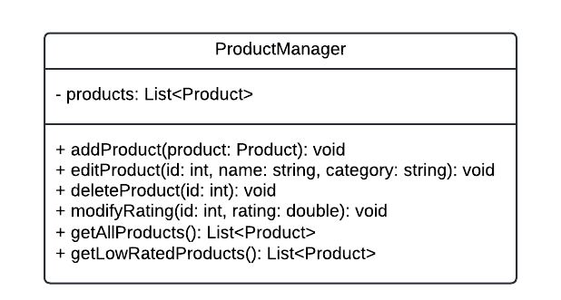
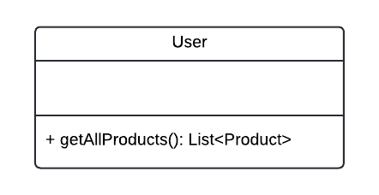
Explanation of class diagram:
In this diagram:
- *Product*: Represents a product with attributes such as id, name, category, and rating. It has methods to get and set these attributes.
- *ProductManager*: Manages the products in the system. It has methods to add, edit, delete products, modify ratings, get all products, and get low-rated products.
- *User*: Represents a user who can retrieve all products along with their ratings.
Workflow of the application:
public class Main {
public static void main(String[] args) {
// Create product manager
ProductManager productManager = new ProductManager();

// Add some initial products
productManager.addProduct(new Product(1, "Laptop", "Electronics"));
productManager.addProduct(new Product(2, "Smartphone", "Electronics"));
productManager.addProduct(new Product(3, "Headphones", "Electronics"));

// Manager modifies the rating of a product
productManager.modifyRating(1, 4.5); // Set Laptop's rating to 4.5

// User requests list of all products with their ratings
List<Product> allProducts = productManager.getAllProducts();
System.out.println("List of all products with their ratings:");
for (Product product : allProducts) {
System.out.println(product.getName() + " - " + product.getRating());
}

// Manager asks for products with low ratings
List<Product> lowRatedProducts = productManager.getLowRatedProducts();
System.out.println("\nList of products with low ratings:");
for (Product product : lowRatedProducts) {
System.out.println(product.getName() + " - " + product.getRating());
}

// Manager deletes a product
productManager.deleteProduct(3); // Delete Headphones

// User requests updated list of all products with their ratings
allProducts = productManager.getAllProducts();
System.out.println("\nUpdated list of all products with their ratings:");
for (Product product : allProducts) {
System.out.println(product.getName() + " - " + product.getRating());
}
}
}
Explanation of the workflow:
In this main function:
- We create a ProductManager instance to manage products.
- Add some initial products.
- Modify the rating of a product.
- Retrieve all products with their ratings and display them.
- Retrieve low-rated products and display them.
- Delete a product.
- Retrieve the updated list of all products with their ratings and display them.

